MV Accredited: Yes ☐ No ☐

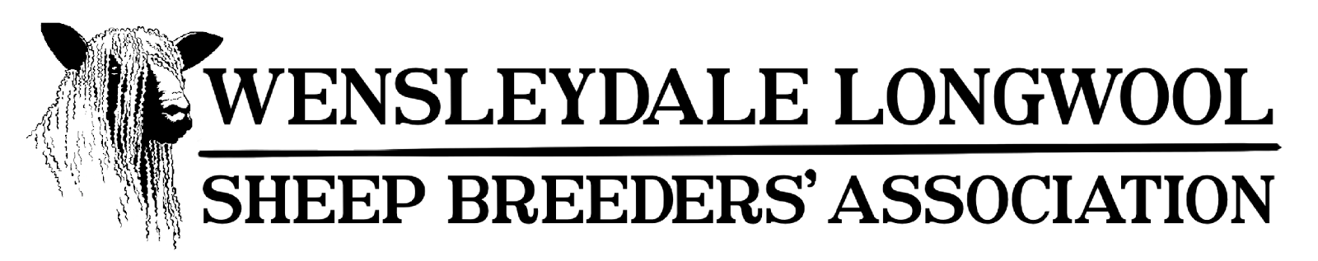
2026 Registrations & Tags
Jodi Shadforth, Crookfoot Farm, Elwick, Hartlepool, County Durham, TS27 3HA www.wlsba.co.uk secretary@wlsba.co.uk 07495320768
Name: Flock Number: | Flock Prefix:
Address: | DEFRA UK Number:
Postcode:  Email: Phone: | CPH Number:  Flock: Section A White ☐ Section B Black ☐
Lamb Registration Change Details - 2026
As of January 1st 2026, the Wensleydale Longwool sheep Breeders’ Association has made some slight adjustments to the tag ordering process. This affects lamb registrations and replacement tag orders for sheep that are already registered. If after reading this registration form you are at all confused about registering lambs or ordering replacement tags, please contact the secretary and she will be more than happy to help you. Below is a description of the below tag types and associated fees for lamb registrations.

Next Sequential WLSBA + EID (matching pair) – If you have not tagged your lambs with a ministry issued UK tag or have used slaughter tags in your lambs, you will require a next sequential pair of tags for each lamb, so please tick this option on the following page. If you have already tagged your lambs with a UK tag, please do not choose this option. This costs £7 per lamb and you will receive a WLSBA tag and matching EID. If you do not know your next sequential number, please leave the ‘Individual Number’ column blank and the secretary will sort this for you.

WLSBA Tag Only – If you have already tagged your lambs with a ministry issued UK EID tag and just want a single replica blue/orange WLSBA tag for the other ear, please tick this option. This costs £7 per lamb and you will receive a single WLSBA tag.

Replica WLSBA + EID (matching pair) – If you have already tagged your lambs with a ministry issued UK tag but would like to cut out the existing tags and replace them with matching pairs of WLSBA and EIDs for each lamb, please choose this option. This costs £9.50 per lamb and you will receive a matching set of replica WLSBA tags.

Management Tag – If you have already tagged your lambs with ministry issued UK tags and would like to insert a third tag into your lamb’s ears, or if you are located in the Republic of Ireland, please choose this option. This costs £7 per lamb and you will receive a WLSBA management tag with only the pedigree number marked on the tag.

Please note that both membership fees and registration fees must be paid before stock can be registered and tags ordered.

Details of Lambs to be Registered
Lambs MUST be registered by 30th November in the year they are born, lamb registrations can only be submitted by the breeder
Sex M/F | Individual Number | Sire Name & Breeding Ram List Number | Dam Tag Number | Single (S) Twin (Tw) Triplet (Tr) | Cost  (£7 per Lamb) | Replica EID Required?  (additional  £2.50)
M | e.g. (UK0123456 00123) | e.g. Fred 1000 | e.g. 1234/12/123 | Tw | £7 | --
Please note that all lamb registrations are £7 each, however there is an additional £2.50 charge if lambs also require a REPLICA EID tag. Replica tags are reprints of tags that have already been issued (where you have already tagged your sheep with an existing ministry tag). Replicas can not be made of slaughter tags. If you are unsure which tags you require, please refer to the first page for more information or contact the secretary before ordering and she will be more than happy to advise you. |  |  |  |  | Total Cost
Type of tags you would like to order for your lamb registrations (please tick one)
Next Sequential WLSBA + EID (matching pair) – Next sequential pair of tags, a WLSBA tag and a yellow EID £7 per Lamb
WLSBA Tag Only – Single replica blue/orange WLSBA tag (for use when you have already tagged with an EID) £7 per Lamb
Replica WLSBA + EID (matching pair) – Replica pair of tags, a WLSBA tag and a yellow EID (cut out existing EID) £9.50 per Lamb
Management Tag – ONLY has WLSBA details (only order if intending on having three tags in ear or for flocks in EIRE) £7 per Lamb

Details of Stud Rams to be entered on Breeding Ram List
Rams MUST be entered by 30th November in the year they are first used for breeding, NOT when their progeny are born
Full WLSBA No  (flock/year/individual) | Breeder | Prefix of Breeder and name you  would like to assign | Sire | Dam tag number | £10 per ram

Replacement Tags (for sheep that have lost a tag) – MUST INCLUDE BOTH WLSBA/EID TAG NUMBERS
PLEASE NOTE - additional £4 postage for replica tags if not tied with a lamb registration order!
Full WLSBA No  (flock/year/individual) | EID tag number | Which tag is required?  (EID/WLSBA) | WLSBA - £2 per tag  EID - £2.50 per tag
e.g. 1234/12/123 | e.g. UK0123456 12345 | e.g. EID & WLSBA | e.g. £4.50

Please sign the below declaration and return the completed forms to:  WLSBA Hon. Secretary Miss Jodi Shadforth Crookfoot Farm  Elwick Hartlepool TS27 3HA  Cheques made payable to:  “Wensleydale Longwool Sheep Breeders’ Association”  Payment can also be made via BACS (preferred):  Wensleydale Longwool Sheep Breeders’ Association  Natwest Account: 04216822  Sort Code: 54-30-23  This signed form can submitted via email as a Word Document or PDF to secretary@wlsba.co.uk | Total Costs | Quantity |  | Cost
 | Ram Lambs (£7 each)
 | Ewe Lambs (£7 each)
 | Breeding Ram (£10 each)
 | Replica EID Tags & Replacement Tags  (£2 WLSBA, £2.50 EID, postage an additional £4 if not tied with a lamb registration order) | WLSBA | EID
 | Tagger (£15 each)
 | Total | £
Declaration

I understand the following:

The Wensleydale Longwool Sheep Breeders’ Association is known as a “data controller” for the purpose of the General Data Protection Regulation (GDPR) 2018. By proceeding to use our service you agree that we may process the personal data that we collect from you in accordance with our Data Protection Policy.

The information we hold about you is your name, address, telephone & mobile numbers and in some cases your email address. We have your UK Flock number, your Holding number and any sheep that you have requested are transferred to your flock or bred by yourself. We do not supply or sell this data to any other organisation for gain. Our pedigree system is operated under the Grassroots system. Our system is backed up onto a hard disc/the cloud and paper copies are securely kept. We hold this information for administration purposes and we may use your details when promoting your sheep/the breed if required and for publication in our annual flock book both in paper print and on our Association website for members access only. Please address any questions, comments and requests to secretary@wlsba.co.uk
Signed: Date:

